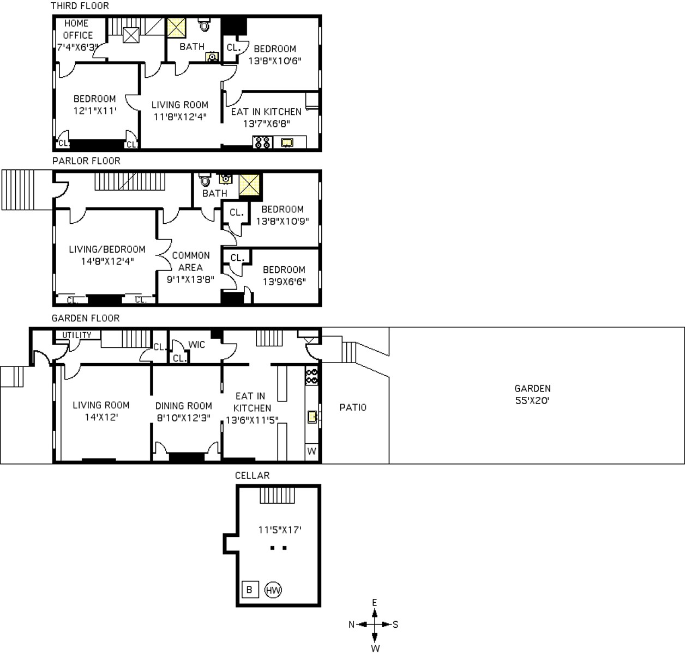
Gary Richman,
Licensed Real Estate Assoc. Broker
David West Properties
Cell 917-561-1915
Office 718-788-3003
Fax 718-475-2035
Gary@davidwestproperties.com
